Practical 10
Code:https://github.com/bhavyakumar18/DSA/tree/main/Practical%2010
Problem 1
I faced difficulty in handling collisions when the calculated parking slot was already occupied. I solved this by checking the next slot one by one and using % 10 to wrap around to slot 0 when I reached the end. I also kept track of the number of attempts so that the program does not keep searching forever when all slots are full.
Output:
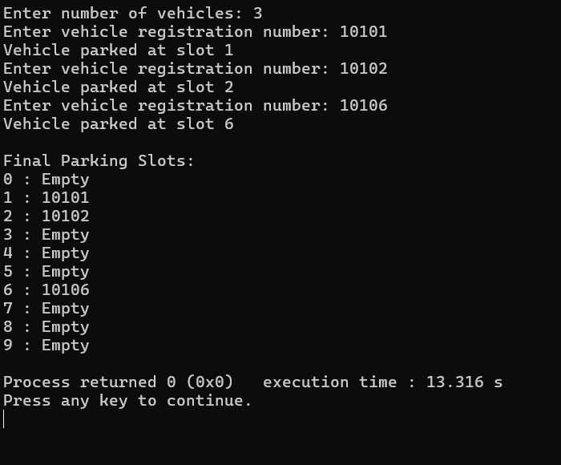
Problem 2
I faced difficulty in handling multiple books that were assigned to the same shelf. I solved this by using a separate stack for each shelf, so multiple books can be stored on the same shelf without replacing each other. I used code % 10 to find the shelf number. As more books are added to one shelf, searching that shelf takes more time.

Output:
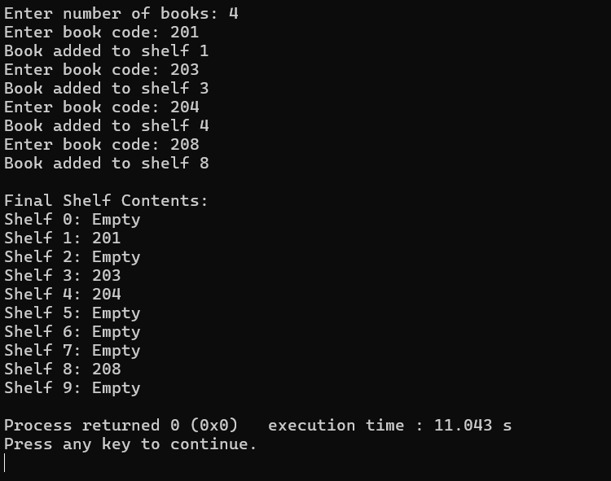

Problem 3
I faced difficulty in understanding how the second hash function decides the jump size during a collision. I solved this by using the first hash function to find the initial slot and the second hash function to calculate the jump size. I then checked the next positions using the calculated jump until an empty slot was found. I also learned that if the jump size and table size have a common factor, some slots may never be checked, so the table can fail to find an available slot even when one exists.
Output:
